**Everything you ask for apart from the data and the resource mapping can be found in the github repository (**[**https://github.com/kdotdot/cerebra_atlas_python/tree/main**](https://github.com/kdotdot/cerebra_atlas_python/tree/main)**). I have attached the mapping as a csv and I will upload the data once I can find a way to get that much space online.**

**First of all you should download and install the library. I have updated the installation instructions, It should be straightforward but If you run into issues do not hesitate to ask for help.**

**a mapping of the coordinates of the 32k points of the average brain, and the regions (62). Basically I need to know which of the 32k points are mapped to each region (62) and from these to the 12 resources (MRT)**

**After installing the library you can find the points mapped to the regions as an array using cerebra.src_space_labels. The default source space contains 31553 points.**

**cerebra.src_space_labels: [79 79 79 ... 28 45 45]**

**cerebra.src_space_labels.shape=(31553,)**

**Details for each label can be found in cerebra._label_details. There are also many other available methods for interacting with the data (cerebra.volume_data), the labels, plotting, and integration with MNE for SL purposes.**

**can you forward or point to the way the mapping cortical-regions to MRT resources has been done in python please?**

**The mapping has not been done in Python but I have attached the csv file which should be enough to determine which regions are mapped to which resources.**

**also could you point to that function that, given the 30k sources (each with a magnitude value), can print the brain in 3d please?**

**For printing the brain in 3d you can use the cerebra.plot3d function with an array of colors as input. Each point should indicate its color.**

**Important: The colors have to be in RGB format as an array of size (n_points,3). For example, for a blue brain**

**from cerebra_atlas_python import CerebrA**

**import matplotlib.pyplot as plt**

**cerebra = CerebrA()**

**colors = [[0.0, 0.0, 1.0]] * len(cerebra.src_space_labels)**

**cerebra.plot3d(colors=colors)**

**plt.show()**

**You can see more code examples here:**[**https://github.com/kdotdot/cerebra_atlas_python/tree/main/examples**](https://github.com/kdotdot/cerebra_atlas_python/tree/main/examples)

* **First Thing Drive mounted**

from google.colab import drive

drive.mount('/content/drive')

* **Import all the necessary packages**

import numpy as np

import matplotlib.pyplot as plt

import seaborn as sns

import pandas as pd

import statistics

* We should load the data

videodata= np.load ("/content/drive/MyDrive/Data TU PHD DUBLIN/First data/video1_eLORETA.npy")

print(len(videodata)) #len of points in brain (31553)

print(videodata[0])

print(len(videodata[0]))  #timestamps  (11250=125hz x 90 seconds)

print(type(videodata))

#video2data is a list of list (first list 31553 lenghth,each of this cell contains 11250 point,31553 is represented the number of the brain and the 11250 is the point in time  )

We will receive the result:

31553

[-1.1421317 -0.62574935 -0.23263833 ... 1.0398824 1.7192281

-1.1194842 ]

11250

<class 'numpy.ndarray'>

* Visualisation of heatmap of brain activation over time
* fig = plt.figure(figsize=(3,4))
* ax = fig.gca()
* ax.imshow(videodata)
* plt.tight_layout()
* plt.xlabel('X-axis', fontsize=10)
* plt.fontsize=10)
* plt.title('Heat map of brain activation over time')
* plt.show()

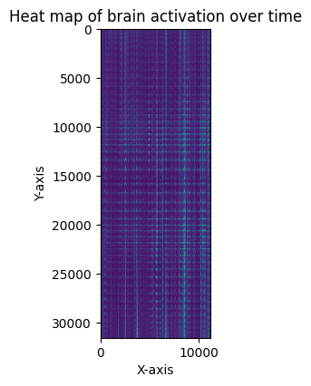

Calculate the Mean and Standard Deviation

meanOfVideoData= np.mean(videodata ,axis=0 )#mean for whole data

stdOfVideoData= np.std(videodata ,axis=0 )#mean for whole data

plt.plot(meanOfVideoData)

plt.xlabel('X Axis')

plt.ylabel('Y Axis')

plt.title('Mean of video data')

plt.show()

plt.plot(stdOfVideoData)

plt.xlabel('X Axis')

plt.ylabel('Y Axis')

plt.title('SD of video data')

plt.show()

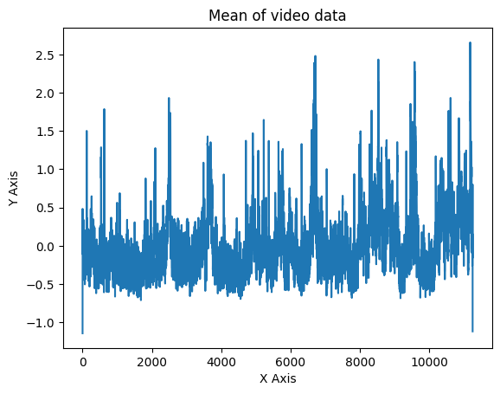

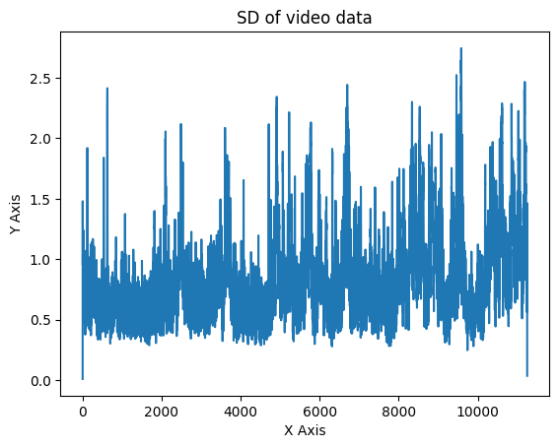

* **VISUALIZE THE FIRST FIVE BRAIN FROM RESOURCE**

<https://mindboggle.readthedocs.io/en/latest/labels.html>

<https://surfer.nmr.mgh.harvard.edu/fswiki/FsTutorial/GcaFormat>

<https://www.frontiersin.org/journals/neuroscience/articles/10.3389/fnins.2012.00171/full>

<https://osf.io/kvx22> metadata

<https://pmc.ncbi.nlm.nih.gov/articles/PMC7363886/> DICE KAPPA EXPLAIN

**Cerebra A (or Cerebral Atlas)**

* **Purpose**: Typically, an atlas like "Cerebra A" is used as a standard reference for identifying specific regions or structures within the brain.
* **Structure**: It consists of a defined set of brain regions, each labeled with coordinates and potentially hierarchical regions. It allows for clear localization of brain structures in studies and comparisons.
* **Use Case**: Researchers use cerebral atlases for analyzing and comparing brain imaging data across studies, helping in consistent identification of regions like the hippocampus, amygdala, and more specific cortical areas.

**2. Mindboggle**

* **Purpose**: Mindboggle is a comprehensive, open-source software package designed for brain morphology and cortical surface analysis. It also includes its own atlas with a set of anatomical labels, enabling standardized labeling and analysis.
* **Features**: Unlike static atlases, Mindboggle integrates advanced processing tools (such as FreeSurfer) to analyze brain shape, volume, surface area, and gyrification. It uses various atlases (including Desikan-Killiany and others) to provide a robust analysis.
* **Use Case**: Mindboggle is often used for research that requires in-depth morphological analysis, providing data on how different brain regions compare structurally and functionally.

**Key Differences:**

* **Purpose**: Cerebra A is a static brain atlas, while Mindboggle is a processing tool with an integrated atlas for morphological analysis.
* **Complexity**: Mindboggle provides complex analysis options and data processing tools, while Cerebra A primarily offers labeled brain regions without additional processing tools.
* **Functionality**: Mindboggle's versatility makes it suitable for a wider range of research applications, particularly those focusing on brain structure and morphology.

|  |  |  |
| --- | --- | --- |
| Caudal Anterior Cingulate | الذيل الأمامي الحزامي | 1002, “left caudal anterior cingulate” |
| Caudal Middle Frontal | الذيل الأوسط الجبهي | 1003, “left caudal middle frontal” |
| Cuneus | العظم الإسفيني | 1005, “left cuneus” |
| Entorhinal | العظم الإسفيني الداخلي | 1006, “left entorhinal” |
| Fusiform | المغزلي | 1007, “left fusiform” |
| Inferior Parietal | الجداري السفلي | 1008, “left inferior parietal” |
| Inferior temporal | الصدغي السفلي | 1009, “left inferior temporal” |
| Isthmus Cingulate | البرزخ الحزامي | 1010, “left isthmus cingulate” |
| Lateral Occipital | القذالي الوحشي | 1011, “left lateral occipital” |
| Lateral Orbitofrontal | العظم الحجاجي الجبهي الوحشي | 1012, “left lateral orbitofrontal” |
| Lingual | اللساني | 1013, “left lingual” |
| Medial Orbitofrontal | العظم الحجاجي الجبهي الإنسي | 1014, “left medial orbitofrontal” |
| Middle Temporal | الصدغي الأوسط | 1015, “left middle temporal” |
| Parahippocampal | المجاور للحُصين | 1016, “left parahippocampal” |
| Paracentral | المجاور للمركزي | 1017, “left paracentral” |
| Pars Opercularis | الجزء الغطائي | 1018, “left pars opercularis” |
| Pars Orbitalis | الجزء الحجاجي | 1019, “left pars orbitalis” |
| Pars Triangularis | الجزء المثلثي | 1020, “left pars triangularis” |
| Pericalcarine | حول الحُصين | 1021, “left pericalcarine” |
| Postcentral | خلف المركزي | 1022, “left postcentral” |
| Posterior Cingulate | الحزام الخلفي | 1023, “left posterior cingulate” |
| Precentral | أمام المركزي | 1024, “left precentral” |
| Precuneus | الجزء الإسفيني | 1025, “left precuneus” |
| Rostral Anterior Cingulate | الحزام الأمامي الأمامي الأمامي | 1026, “left rostral anterior cingulate” |
| Rostral Middle Frontal | الرأسي الأوسط الجبهي | 1027, “left rostral middle frontal” |
| Superior Frontal | الجبهي العلوي | 1028, “left superior frontal” |
| Superior Parietal | الجداري العلوي | 1029, “left superior parietal” |
| Superior Temporal | الصدغي العلوي | 1030, “left superior temporal” |
| Supramarginal | فوق الهامشي | 1031, “left supramarginal” |
| Transverse Temporal | الصدغي المستعرض | 1034, “left transverse temporal” |
| Insula | الجزيرة | 1035, “left insula” |
| Brainstem | جذع الدماغ | 2002, “right caudal anterior cingulate” |
| Third Ventricle | البطين الثالث | 2003, “right caudal middle frontal” |
| Fourth Ventricle | البطين الرابع | 2005, “right cuneus” |
| Optic Chiasm | التصالب البصري | 2006, “right entorhinal” |
| Lateral Ventricle | البطين الجانبي | 2007, “right fusiform” |
| Inferior Lateral Ventricle | الجانبي السفلي البطين | 2008, “right inferior parietal” |
| Cerebellum Gray Matter | المادة الرمادية للمخيخ | 2009, “right inferior temporal” |
| Cerebellum White Matter | المادة البيضاء للمخيخ | 2010, “right isthmus cingulate” |
| Thalamus | المهاد | 2011, “right lateral occipital” |
| Caudate | الذنبي | 2012, “right lateral orbitofrontal” |
| Putamen | البطمان | 2013, “right lingual” |
| Pallidum | الشاحب | 2014, “right medial orbitofrontal” |
| Hippocampus | الحُصين | 2015, “right middle temporal” |
| Amygdala | اللوزة | 2016, “right parahippocampal” |
| Accumbens Area | منطقة المتكئة | 2017, “right paracentral” |
| Ventral Diencephalon | الدماغ البيني البطني | 2018, “right pars opercularis” |
| Basal Forebrain | الدماغ الأمامي القاعدي | 2019, “right pars orbitalis” |
| Vermal lobules I-V | الفصيصات الوتدية I-V | 2020, “right pars triangularis” |
| Vermal lobules VI-VII | الفصيصات الوتدية VI-VII | 2021, “right pericalcarine” |
| Vermal lobules VIII-X | الفصيصات الوتدية VIII-X | 2022, “right postcentral” |
|  |  | 62 |
|  |  | 2023, “right posterior cingulate” |
|  |  | 2024, “right precentral” |
|  |  | 2025, “right precuneus” |
|  |  | 2026, “right rostral anterior cingulate” |
|  |  | 2027, “right rostral middle frontal” |
|  |  | 2028, “right superior frontal” |
|  |  | 2029, “right superior parietal” |
|  |  | 2030, “right superior temporal” |
|  |  | 2031, “right supramarginal” |
|  |  | 2034, “right transverse temporal” |
|  |  | 2035, “right insula” |
|  |  |  |
|  |  |  |
|  |  |  |
|  |  |  |

